Host Richard Bangs
Adventures with Purpose

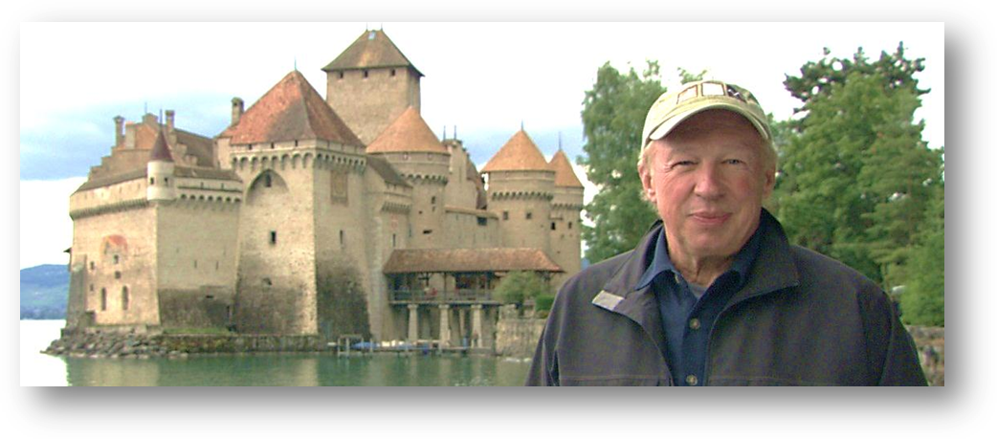
Richard Bangs has been called the father of modern adventure travel and a pioneer in travel with a purpose. He has spent 30 years as an explorer and communicator, and along the way led first descents of 35 rivers around the globe, including the Yangtze in China and the Zambezi in Southern Africa.

Richard has published hundreds of magazine articles, 18 books, a score of documentaries and several CD-ROMs; and has lectured at the Smithsonian, the National Geographic Society, and the Explorers Club. He writes semi-regular features for the Huffington Post. Bangs was founder and editor-in-chief of Mungo Park, a pioneering Microsoft travel publishing effort, and founded Terra Quest. He was part of the founding executive team of Expedia.com, and served as its Editor-at-Large. Richard was creator and publisher of Expedia Travels Magazine (a partnership with Ziff-Davis), executive producer of Expedia Radio, and founder and executive director of Expedia Cafes. He also served as president of Outward Bound; Founded Well-Traveled for Slate, and was founding editor and executive producer of Great Escapes, another Microsoft Travel initiative. He ran and founded First and Best for MSN, and founded Sobek Expeditions, which in the early 1990s merged with Mountain Travel to become Mountain Travel Sobek. Richard’s book, The Lost River: A Memoir of Life, Death and the Transformation of Wild Water, was honored with a National Outdoor Book Award in literature. He served as executive producer of Richard Bangs Adventures on Yahoo. More recently, he was host, co-executive producer and co-writer for the 12 episode American Public Television series Adventures with Purpose produce by Small World productions of Seattle and co-produced by KCTS/ Seattle.

Adventures with Purpose | Small World Productions  140 Lakeside, Suite 200, Seattle 98122  206.329.7167  info@travelsmallworld.com  www.AdventuresWithPurpose.TV
the production team
Adventures with Purpose

For twenty-five years, Small World Productions has produced substantial, content-driven travel series for public television. The Seattle-based company has released more than 170 episodes and six pledge specials that are popular with public television programmers and viewers. This body of work has resulted in the release of more than 160 home video and DVD titles. In addition to Adventures with Purpose, Small World production credits include: Smart Travels – Europe: Series I, II, III, and IV, Smart Travels—Pacific Rim: Series V, Travels in Europe with Rick Steves: Series I, II, III and IV, Travels in Mexico and the Caribbean with Shari Belafonte, and America's Historic Trails with Tom Bodett.

Small World partners John Givens, Patricia Larson and Sandra Nisbet created the popular national series, Smart Travels. In addition to their body of work with Small World, Larson and Nisbet have a background in theater, history, play writing, international travel, and college teaching. Executive producer and CEO Givens has produced, directed and edited public television programs for more than forty-years. In 2000, he was honored with a Most Valuable Producer Award from American Public Television, and in 2007 with an APT Programming Excellence Award. An avid traveler, Givens has visited more than 60 countries.

Larson and Nisbet first teamed with Givens in 1980 to make public television programs supported by the National Endowment for the Humanities, the Washington Commission for the Humanities, and the Washington State Arts Commission. Their credits include a dramatic series Take it To The People hosted by Stanley Kramer, an award-winning documentary Everything Change, Everything Change, and eleven public television travel series.

For Adventures with Purpose, Small World is joined again by our excellent team of award-winning photographers, editors and producers.

- Patty Conroy has produced and written more than fifty travel episodes for Small World. She has been honored with Emmys Awards, CINE Golden Eagles, Lowell Thomas Gold Awards and Silver Telly Awards. Patty’s national credits include Smart Travels, Travels in Europe with Rick Steves, America’s Historic Trails with Tom Bodett, and Travels in Mexico and the Caribbean with Shari Belafonte.

- Editor David Ris brings unique skills and knowledge of high-definition television production to the project. He has edited more than 60 HD travel episodes for Small World, including two-dozen Smart Travels and Adventures with Purpose shows honored with national or international awards. In addition to creative editing, David composes original music for Adventures with Purpose and he is the on-line editor for all episodes.

- Karel Bauer is the director of photography for six episodes of Adventures with Purpose. His other national credits include Rick Steves’ Europe, Travels to the Edge with Art Wolfe, several Nature docs and a number of Discovery Channel and National Geographic projects.

- Sara Givens is Production Manager and Assistant Editor. Sara has a degree in Film and Video from The Evergreen State College and has traveled extensively with the AWP and Smart Travels crews.
Adventures with Purpose | Small World Productions  140 Lakeside, Suite 200, Seattle 98122  206.329.7167  info@travelsmallworld.com  www.AdventuresWithPurpose.TV

